Ketchup Tips & Plus Ones

BBQ Ketchup
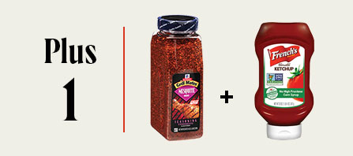 | Add the sweet and smoky flavor of true southern barbecue to ketchup with this quick plus one. Combine one cup of French’s® Tomato Ketchup + one tablespoon of Grill Mates® Mesquite Seasoning.

Curried Ketchup
Add the authentic tastes of Indian and Southeast Asian cuisine to ketchup with this Curried Ketchup recipe. Simply mix one cup of French’s Tomato Ketchup + one tablespoon of McCormick® Culinary Curry Powder.

OLD BAY® Ketchup
Create a ketchup that is sweet, spicy, and savory all at once with the unique seasoning consumers love! Simply mix one cup of French’s Tomato Ketchup + one tablespoon of OLD BAY Seasoning.

Sriracha Ketchup
Give ketchup an extra kick with an exciting blend of sun-kissed chili peppers, robust jalapeños and smoked paprika. Just mix one cup of French’s Tomato Ketchup + one tablespoon of Frank's RedHot® Sriracha Chili Sauce.

Smoky Ketchup
Bring a sweet yet smoky flavor to ketchup without adding too much heat. Combine one cup of French’s Tomato Ketchup + one tablespoon of McCormick Culinary Smoked Paprika.

