Montreal BBQ Sauce
 | 1 tablespoon Montreal Steak Seasoning +1 cup Cattlemen’s Original Base BBQ Sauce

Signature Pizza Sauce
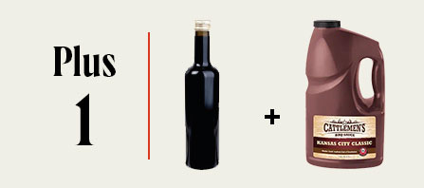 | ¼ cup Balsamic Vinegar + 2 cups Cattlemen’s Kansas City Classic

Spicy Tangy BBQ Sauce
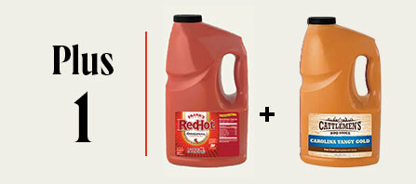 | ¾ cup Frank’s Original Cayenne Pepper Sauce + ¾ cup Cattlemen’s Carolina Tangy Gold BBQ Sauce

Sweet and Sour BBQ Sauce
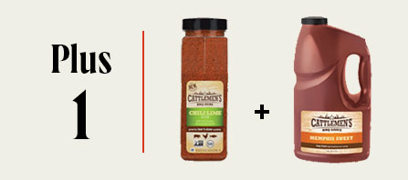 | 1 tablespoon Cattlemen’s Chili Lime Rub +2 cups Memphis Sweet

BBQ Butter
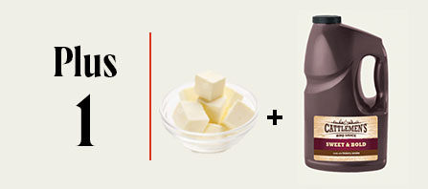 | 3 cups Butter + 1 ½ cups Cattlemen’s Sweet & Bold BBQ Sauce

